Call Center Dashboard Analysis
Ankit Meena¹, Dr. Logeswari P ²
dept. School of Computer Application¹²
Lovely Professional University
Phagwara, Punjab, India¹²
ankitjarwalll@gmail.com1
drLogeswari@gmail.com1

Introduction:
In today's dynamic business landscape, where customer-centricity is paramount, the efficiency and effectiveness of call centers play a pivotal role in shaping the customer experience. With the ever-increasing volume of customer interactions, understanding the intricacies of call center operations is essential for optimizing service quality and customer satisfaction.
The "Call Center Dashboard" presented in this report is a powerful tool that provides a comprehensive view of key performance indicators and insights into our call center's operations. This dashboard encapsulates a wealth of data, enabling us to evaluate the reasons behind customer calls, measure customer satisfaction (CSAT), analyse call volumes, and scrutinize response times. It also offers a geographic perspective by breaking down call data by city and state within the United States.
As we delve into this report, we will explore the findings and trends that emerge from the data visualizations and analytics presented within the dashboard. By deciphering the information contained within, we aim to uncover actionable insights that can guide us in optimizing our call center's operations and, in turn, elevate the overall quality of customer service.
The following sections will provide a detailed analysis of the key findings, the underlying data, and recommendations for improving our call center performance. Through this report, we endeavour to equip stakeholders and decision-makers with valuable information to make informed choices that enhance the effectiveness of our call center, ultimately ensuring customer satisfaction and loyalty.

Dashboard Overview:
The "Call Center Dashboard" is a comprehensive and visually rich representation of our call center's performance and customer interactions. Designed with the aim of providing a holistic view of the operations, it incorporates a range of key performance indicators and data visualizations that enable stakeholders to assess various aspects of our call center's activities. Here is a brief overview of the main components of the dashboard:

- Reason for Calls Breakdown: The dashboard includes a breakdown of the primary reasons for customer calls. This section highlights common issues and concerns, such as billing questions, payment inquiries, and service outages, allowing us to pinpoint areas that require special attention.

- Customer Satisfaction (CSAT) Score: Our CSAT score is a critical measure of customer contentment. The dashboard provides an up-to-date representation of this score, which helps us gauge customer sentiment and satisfaction levels over time.
- Call Volume Statistics: To understand the workload on our call center, the dashboard presents data on the total number of calls received. It also includes a distribution of calls based on the reasons customers are contacting us.
- Average Call Duration: This section focuses on the average duration of customer calls. Monitoring this metric helps us assess the efficiency of our call center agents and can provide insights into potential process improvements.

- Geographic Distribution: For a regional perspective, the dashboard breaks down call data by city and state within the United States. This feature is valuable for identifying areas with particularly high or low call volumes.

- Weekday Call Analysis: By analysing the number of calls received on different days of the week, we can identify trends and allocate resources more effectively during peak call times.

- Response Time Percentage: This metric measures our responsiveness by tracking the percentage of calls answered within a specified time frame. It is crucial for managing customer expectations and ensuring timely assistance.

Key Findings:
Within the "Call Center Dashboard," several critical insights and trends have emerged, shedding light on the performance and dynamics of our call center operations. These key findings provide valuable information for stakeholders and decision-makers, helping us understand our customers' needs and improve service quality. Here are the most significant findings:

Primary Reasons for Customer Calls:
- The top reasons for customer calls include billing questions, payment issues, and service outages.
- Understanding these primary reasons allows us to allocate resources effectively and address common customer concerns promptly.

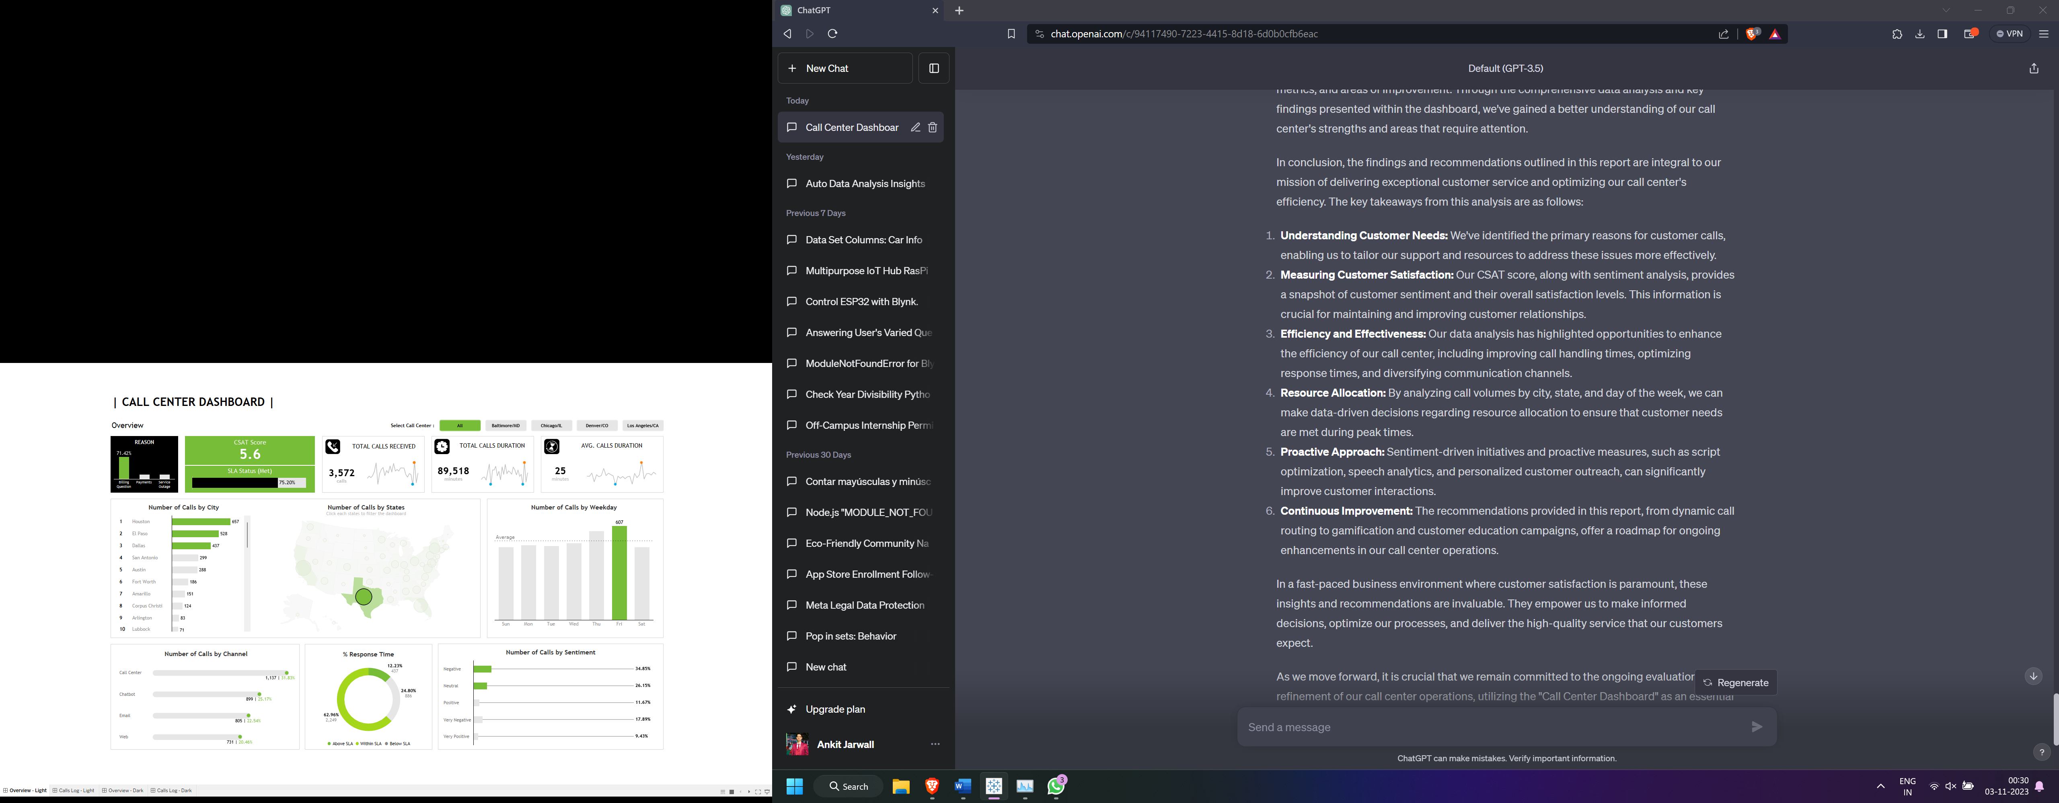
Fig 1: Reasons for Customer Calls

Customer Satisfaction (CSAT) Score:
- Our current CSAT score is 5.6, reflecting overall customer satisfaction.
- We have observed a positive trend in our CSAT score over the past 6 months.

Fig 2: Customer Satisfaction (CSAT) Score

Call Volume Statistics:
- We receive an average of 496 calls per day.
- The distribution of calls by reason shows that billing questions, payment represents the largest share of our call volume.

Fig 3: Call Volume Statistic

Average Call Duration:
- The average call duration is approximately 25 minutes, which suggests we have more scope of improvement to bring it under 10 minutes.

Fig 4: Total call Duration

Fig 5: Avg. Calls Durations

Geographic Distribution:
- This information can guide our marketing and service strategies in regions with high or low call volumes.
Fig 6: Number of Calls by City

Fig 7: Number of Calls by States

Weekday Call Analysis:
- The dashboard reveals that Friday consistently witness the highest call volumes.
- Adjusting staffing levels to accommodate this peak in calls can lead to a more efficient call center operation.
Fig 8: Number of Calls by Weekday

Response Time Percentage:
- 62.96% of calls are answered within 4 minutes.
- We need to maintain and potentially improve this response time to meet customer expectations.
Fig 9: Response Time in Percentage

Fig 10: Number of calls by Channel

Fig 1: Light Theme Call Center Dashboard Analysis
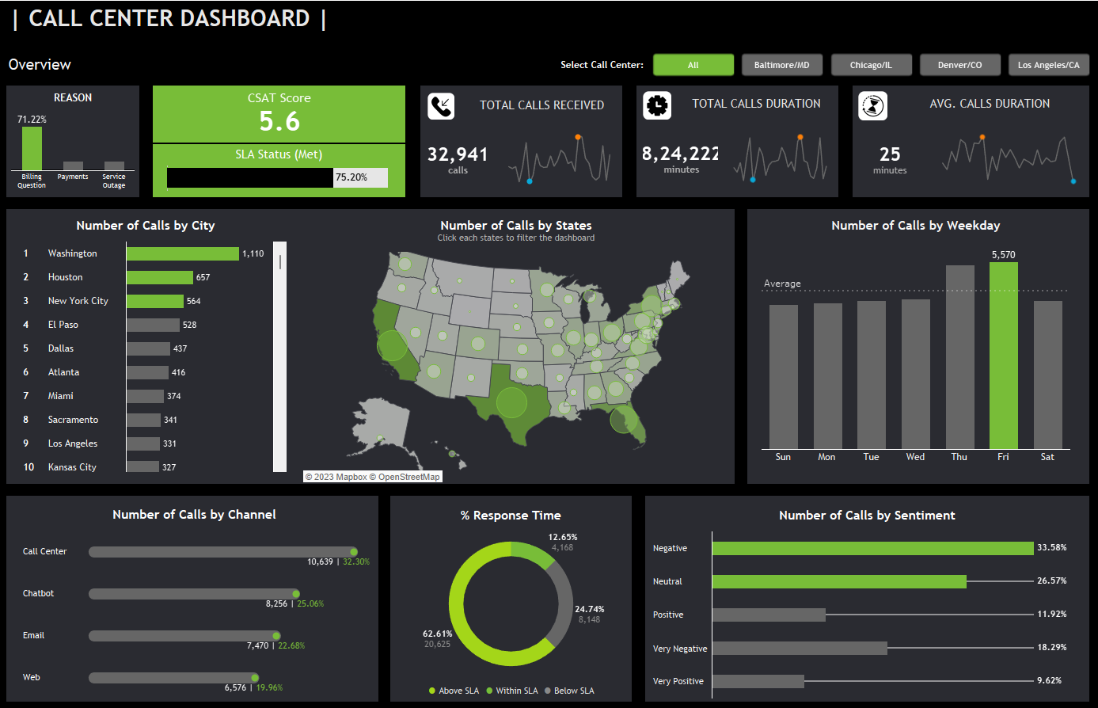
Fig 2: Dark Theme Call Center Dashboard Analysis

Recommendations
Dynamic Call Routing System: Implement a dynamic call routing system that directs calls to the most suitable agents based on their expertise and the nature of the call. This approach ensures that customers receive faster and more accurate assistance.
Predictive Analysis for Peak Call Times: Employ predictive analysis to anticipate peak call times based on historical data, events, or promotions. By proactively adjusting staffing during these periods, we can reduce customer wait times and enhance their experience.
Speech Analytics for Call Quality: Invest in speech analytics tools to evaluate the quality of customer-agent interactions. This technology can identify areas for improvement in call center conversations, leading to better service delivery.
Personalized Customer Outreach: Utilize customer data and insights to initiate proactive outreach to specific customer segments. For instance, reaching out to customers who frequently face billing issues with personalized support or information can reduce call volumes.
A/B Testing for Script Optimization: Conduct A/B testing of call scripts to identify the most effective language and strategies in addressing customer concerns. Regularly optimizing scripts can lead to more efficient and satisfactory interactions.
Chatbot Integration: Integrate chatbots to handle routine inquiries and common customer issues. This not only reduces call volumes but also offers customers an additional and convenient channel of support.
Sentiment-Driven Rewards: Develop a sentiment-driven rewards program for call center agents. Reward employees for improving customer sentiment and service quality, fostering a positive work environment.
Gamification for Employee Engagement: Implement gamification techniques to keep call center agents engaged and motivated. Competitive challenges and rewards can boost performance and service levels.
Customer Self-Service Portals: Develop comprehensive self-service portals that allow customers to find answers to common questions, check their billing status, and troubleshoot common issues independently, reducing the need for calls.
Cross-Training of Agents: Cross-train call center agents to handle a wider range of issues. This can lead to improved call resolution rates, shorter call durations, and enhanced customer satisfaction.
Customer Education Campaigns: Launch educational campaigns to inform customers about common issues and how to resolve them. This proactive approach can prevent calls related to well-documented problems.
Integrated CRM System: Implement an integrated Customer Relationship Management (CRM) system to provide call center agents with a holistic view of customer history, enabling more personalized and efficient interactions.

Conclusion
In conclusion, the findings and recommendations outlined in this report are integral to our mission of delivering exceptional customer service and optimizing our call center's efficiency. The key takeaways from this analysis are as follows:
- Understanding Customer Needs: We've identified the primary reasons for customer calls, enabling us to tailor our support and resources to address these issues more effectively.
- Measuring Customer Satisfaction: Our CSAT score, along with sentiment analysis, provides a snapshot of customer sentiment and their overall satisfaction levels. This information is crucial for maintaining and improving customer relationships.
- Efficiency and Effectiveness: Our data analysis has highlighted opportunities to enhance the efficiency of our call center, including improving call handling times, optimizing response times, and diversifying communication channels.
- Resource Allocation: By analysing call volumes by city, state, and day of the week, we can make data-driven decisions regarding resource allocation to ensure that customer needs are met during peak times.
- Proactive Approach: Sentiment-driven initiatives and proactive measures, such as script optimization, speech analytics, and personalized customer outreach, can significantly improve customer interactions.
- Continuous Improvement: The recommendations provided in this report, from dynamic call routing to gamification and customer education campaigns, offer a roadmap for ongoing enhancements in our call center operations.

In a fast-paced business environment where customer satisfaction is paramount, these insights and recommendations are invaluable. They empower us to make informed decisions, optimize our processes, and deliver the high-quality service that our customers expect.
As we move forward, it is crucial that we remain committed to the ongoing evaluation and refinement of our call center operations, utilizing the "Call Center Dashboard" as an essential tool. By implementing these recommendations and embracing innovation, we can further raise the bar for customer service, ensuring that every interaction leaves a positive impression and contributes to the continued success of our organization.

